**User Management Subsystem Functional Requirements, v0.3**

**Author: Josh Trimm**

**Edited by Phil Pfeiffer**

**Last Updated 12 September 2021**

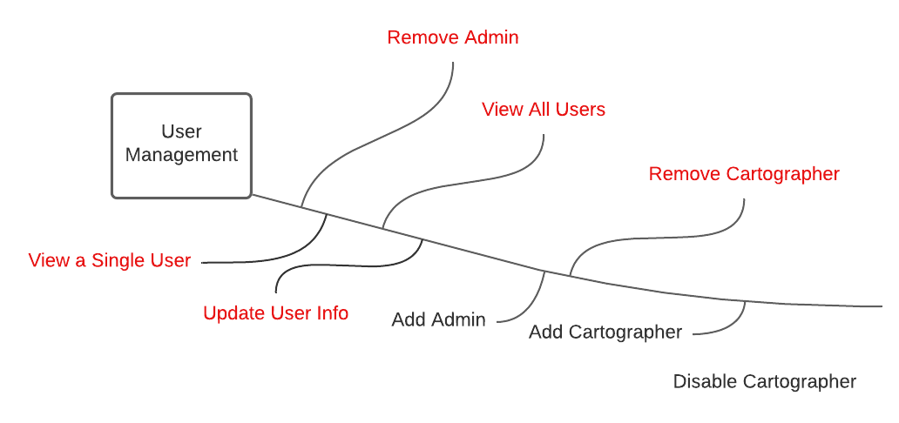

# Description

The User Management system will extent the functionality of Microsoft’s Identity Platform. This system is where Admins will be able to manage all users register with the system.

# Functional Requirements

1. The User Management System shall extend Microsoft’s ASP.NET Core Identity Platform.
2. The system shall always ensure that at least one user has Admin permissions.
3. The system shall allow Admins to add new Cartographers.
4. The system shall allow Admins to add additional Admins.
5. The system shall enable Admins to view information about a system’s users, including
   1. all of the system’s registered users.
   2. for every user, all of that user’s attributes – i.e., name, e-mail address, contact information – with the exception of that user’s password
6. The system shall support the updating of user attributes
   1. The system shall allow users to update their account’s attributes, including their passwords.
   2. The system shall allow Admins to manage any user’s account: i.e.,
      1. to update any of a user’s account’s attributes, excluding passwords.
      2. And to allow CPH Admins to reset user passwords
      3. Allowing users to re-enter a new password via email notification and link.
      4. Admins shall be able to disable a user’s account.
7. The system shall allow Admins to remove a user.
   1. Before removing a user, the system shall show the Admin the names of all charts and regions that that user owns.
   2. The system shall require Admins to confirm the removal.
   3. The system shall transfer ownership of charts and regions to a specified user upon removal of their owner.
      1. The system shall prompt the Admin for a user to whom to transfer ownership.